PCA/FA MLR Proect

## Setup root directory for R Markdown

knitr::opts_knit$set(root.dir = 'C:/Users/Hp/Desktop/R Programming')

## Environment Setup

setwd("C:/Users/Hp/Desktop/R Programming")  
getwd()

## [1] "C:/Users/Hp/Desktop/R Programming"

## Data Import

Data1 <- read.csv("Factor-Hair-Revised.csv", header = TRUE)  
head(Data1)

## ID ProdQual Ecom TechSup CompRes Advertising ProdLine SalesFImage  
## 1 1 8.5 3.9 2.5 5.9 4.8 4.9 6.0  
## 2 2 8.2 2.7 5.1 7.2 3.4 7.9 3.1  
## 3 3 9.2 3.4 5.6 5.6 5.4 7.4 5.8  
## 4 4 6.4 3.3 7.0 3.7 4.7 4.7 4.5  
## 5 5 9.0 3.4 5.2 4.6 2.2 6.0 4.5  
## 6 6 6.5 2.8 3.1 4.1 4.0 4.3 3.7  
## ComPricing WartyClaim OrdBilling DelSpeed Satisfaction  
## 1 6.8 4.7 5.0 3.7 8.2  
## 2 5.3 5.5 3.9 4.9 5.7  
## 3 4.5 6.2 5.4 4.5 8.9  
## 4 8.8 7.0 4.3 3.0 4.8  
## 5 6.8 6.1 4.5 3.5 7.1  
## 6 8.5 5.1 3.6 3.3 4.7

## Invoke Libraries

library(ggplot2)  
library(corrplot)

## Warning: package 'corrplot' was built under R version 3.6.1

## corrplot 0.84 loaded

library(psych)

## Warning: package 'psych' was built under R version 3.6.1

##   
## Attaching package: 'psych'

## The following objects are masked from 'package:ggplot2':  
##   
## %+%, alpha

library(nFactors)

## Warning: package 'nFactors' was built under R version 3.6.1

## Loading required package: MASS

## Loading required package: boot

##   
## Attaching package: 'boot'

## The following object is masked from 'package:psych':  
##   
## logit

## Loading required package: lattice

##   
## Attaching package: 'lattice'

## The following object is masked from 'package:boot':  
##   
## melanoma

##   
## Attaching package: 'nFactors'

## The following object is masked from 'package:lattice':  
##   
## parallel

library(car)

## Warning: package 'car' was built under R version 3.6.1

## Loading required package: carData

##   
## Attaching package: 'car'

## The following object is masked from 'package:boot':  
##   
## logit

## The following object is masked from 'package:psych':  
##   
## logit

library(caTools)

## Warning: package 'caTools' was built under R version 3.6.1

## Exploratory Data Analysis

Mydata <- Data1[,-1]  
  
head(Mydata)

## ProdQual Ecom TechSup CompRes Advertising ProdLine SalesFImage  
## 1 8.5 3.9 2.5 5.9 4.8 4.9 6.0  
## 2 8.2 2.7 5.1 7.2 3.4 7.9 3.1  
## 3 9.2 3.4 5.6 5.6 5.4 7.4 5.8  
## 4 6.4 3.3 7.0 3.7 4.7 4.7 4.5  
## 5 9.0 3.4 5.2 4.6 2.2 6.0 4.5  
## 6 6.5 2.8 3.1 4.1 4.0 4.3 3.7  
## ComPricing WartyClaim OrdBilling DelSpeed Satisfaction  
## 1 6.8 4.7 5.0 3.7 8.2  
## 2 5.3 5.5 3.9 4.9 5.7  
## 3 4.5 6.2 5.4 4.5 8.9  
## 4 8.8 7.0 4.3 3.0 4.8  
## 5 6.8 6.1 4.5 3.5 7.1  
## 6 8.5 5.1 3.6 3.3 4.7

dim(Mydata)

## [1] 100 12

summary(Mydata)

## ProdQual Ecom TechSup CompRes   
## Min. : 5.000 Min. :2.200 Min. :1.300 Min. :2.600   
## 1st Qu.: 6.575 1st Qu.:3.275 1st Qu.:4.250 1st Qu.:4.600   
## Median : 8.000 Median :3.600 Median :5.400 Median :5.450   
## Mean : 7.810 Mean :3.672 Mean :5.365 Mean :5.442   
## 3rd Qu.: 9.100 3rd Qu.:3.925 3rd Qu.:6.625 3rd Qu.:6.325   
## Max. :10.000 Max. :5.700 Max. :8.500 Max. :7.800   
## Advertising ProdLine SalesFImage ComPricing   
## Min. :1.900 Min. :2.300 Min. :2.900 Min. :3.700   
## 1st Qu.:3.175 1st Qu.:4.700 1st Qu.:4.500 1st Qu.:5.875   
## Median :4.000 Median :5.750 Median :4.900 Median :7.100   
## Mean :4.010 Mean :5.805 Mean :5.123 Mean :6.974   
## 3rd Qu.:4.800 3rd Qu.:6.800 3rd Qu.:5.800 3rd Qu.:8.400   
## Max. :6.500 Max. :8.400 Max. :8.200 Max. :9.900   
## WartyClaim OrdBilling DelSpeed Satisfaction   
## Min. :4.100 Min. :2.000 Min. :1.600 Min. :4.700   
## 1st Qu.:5.400 1st Qu.:3.700 1st Qu.:3.400 1st Qu.:6.000   
## Median :6.100 Median :4.400 Median :3.900 Median :7.050   
## Mean :6.043 Mean :4.278 Mean :3.886 Mean :6.918   
## 3rd Qu.:6.600 3rd Qu.:4.800 3rd Qu.:4.425 3rd Qu.:7.625   
## Max. :8.100 Max. :6.700 Max. :5.500 Max. :9.900

str(Mydata)

## 'data.frame': 100 obs. of 12 variables:  
## $ ProdQual : num 8.5 8.2 9.2 6.4 9 6.5 6.9 6.2 5.8 6.4 ...  
## $ Ecom : num 3.9 2.7 3.4 3.3 3.4 2.8 3.7 3.3 3.6 4.5 ...  
## $ TechSup : num 2.5 5.1 5.6 7 5.2 3.1 5 3.9 5.1 5.1 ...  
## $ CompRes : num 5.9 7.2 5.6 3.7 4.6 4.1 2.6 4.8 6.7 6.1 ...  
## $ Advertising : num 4.8 3.4 5.4 4.7 2.2 4 2.1 4.6 3.7 4.7 ...  
## $ ProdLine : num 4.9 7.9 7.4 4.7 6 4.3 2.3 3.6 5.9 5.7 ...  
## $ SalesFImage : num 6 3.1 5.8 4.5 4.5 3.7 5.4 5.1 5.8 5.7 ...  
## $ ComPricing : num 6.8 5.3 4.5 8.8 6.8 8.5 8.9 6.9 9.3 8.4 ...  
## $ WartyClaim : num 4.7 5.5 6.2 7 6.1 5.1 4.8 5.4 5.9 5.4 ...  
## $ OrdBilling : num 5 3.9 5.4 4.3 4.5 3.6 2.1 4.3 4.4 4.1 ...  
## $ DelSpeed : num 3.7 4.9 4.5 3 3.5 3.3 2 3.7 4.6 4.4 ...  
## $ Satisfaction: num 8.2 5.7 8.9 4.8 7.1 4.7 5.7 6.3 7 5.5 ...

attach(Mydata)

## Checking for Null Values

sum(is.na(Mydata))

## [1] 0

## Check for outliers

boxplot(Mydata, main = "Boxplot of Product Service Management Variables")

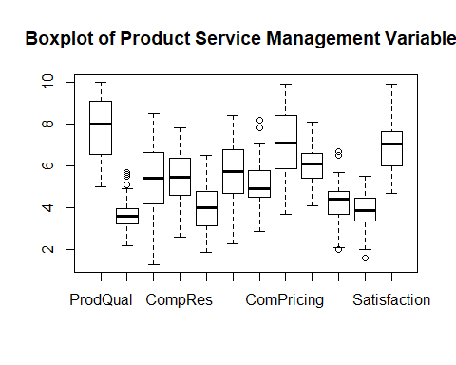

## Univariate Analsis (Dependent Variable)

qplot(Satisfaction, data = Mydata, ylab = "Rating",  
 xlab = "Customer Satisfaction",  
 main = "Histogram of Customer Satisfaction") + geom_histogram(bins = 35) + theme(plot.title = element_text(hjust = 0.5))

## `stat_bin()` using `bins = 30`. Pick better value with `binwidth`.

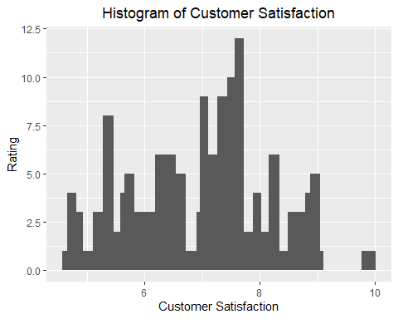

## Check for multicollinearity using corrplot

Matrix <- cor(Mydata[,-12])  
head(Matrix)

## ProdQual Ecom TechSup CompRes Advertising  
## ProdQual 1.00000000 -0.1371632174 0.0956004542 0.1063700 -0.05347313  
## Ecom -0.13716322 1.0000000000 0.0008667887 0.1401793 0.42989071  
## TechSup 0.09560045 0.0008667887 1.0000000000 0.0966566 -0.06287007  
## CompRes 0.10637000 0.1401792611 0.0966565978 1.0000000 0.19691685  
## Advertising -0.05347313 0.4298907110 -0.0628700668 0.1969168 1.00000000  
## ProdLine 0.47749341 -0.0526878383 0.1926254565 0.5614170 -0.01155082  
## ProdLine SalesFImage ComPricing WartyClaim OrdBilling  
## ProdQual 0.47749341 -0.15181287 -0.4012819 0.08831231 0.10430307  
## Ecom -0.05268784 0.79154371 0.2294624 0.05189819 0.15614733  
## TechSup 0.19262546 0.01699054 -0.2707867 0.79716793 0.08010182  
## CompRes 0.56141695 0.22975176 -0.1279543 0.14040830 0.75686859  
## Advertising -0.01155082 0.54220366 0.1342169 0.01079207 0.18423559  
## ProdLine 1.00000000 -0.06131553 -0.4949484 0.27307753 0.42440825  
## DelSpeed  
## ProdQual 0.02771800  
## Ecom 0.19163607  
## TechSup 0.02544069  
## CompRes 0.86509170  
## Advertising 0.27586308  
## ProdLine 0.60185021

corrplot(Matrix)

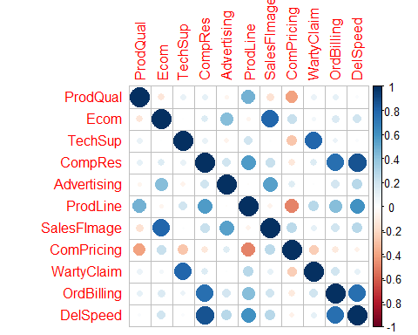

corrplot(Matrix, method = "number" , type = "upper")

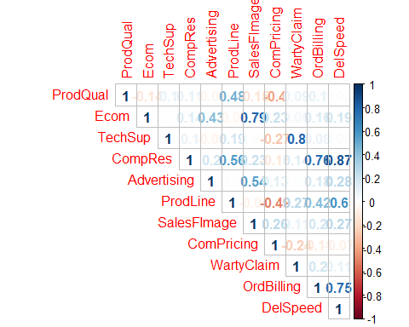

## Check for multicollinearity using VIF (Atleast 1 VIF vallue greater than 4)

M1 <- lm(Satisfaction~., data = Mydata)  
summary(M1)

##   
## Call:  
## lm(formula = Satisfaction ~ ., data = Mydata)  
##   
## Residuals:  
## Min 1Q Median 3Q Max   
## -1.43005 -0.31165 0.07621 0.37190 0.90120   
##   
## Coefficients:  
## Estimate Std. Error t value Pr(>|t|)   
## (Intercept) -0.66961 0.81233 -0.824 0.41199   
## ProdQual 0.37137 0.05177 7.173 2.18e-10 ***  
## Ecom -0.44056 0.13396 -3.289 0.00145 **   
## TechSup 0.03299 0.06372 0.518 0.60591   
## CompRes 0.16703 0.10173 1.642 0.10416   
## Advertising -0.02602 0.06161 -0.422 0.67382   
## ProdLine 0.14034 0.08025 1.749 0.08384 .   
## SalesFImage 0.80611 0.09775 8.247 1.45e-12 ***  
## ComPricing -0.03853 0.04677 -0.824 0.41235   
## WartyClaim -0.10298 0.12330 -0.835 0.40587   
## OrdBilling 0.14635 0.10367 1.412 0.16160   
## DelSpeed 0.16570 0.19644 0.844 0.40124   
## ---  
## Signif. codes: 0 '***' 0.001 '**' 0.01 '*' 0.05 '.' 0.1 ' ' 1  
##   
## Residual standard error: 0.5623 on 88 degrees of freedom  
## Multiple R-squared: 0.8021, Adjusted R-squared: 0.7774   
## F-statistic: 32.43 on 11 and 88 DF, p-value: < 2.2e-16

vif(M1)

## ProdQual Ecom TechSup CompRes Advertising ProdLine   
## 1.635797 2.756694 2.976796 4.730448 1.508933 3.488185   
## SalesFImage ComPricing WartyClaim OrdBilling DelSpeed   
## 3.439420 1.635000 3.198337 2.902999 6.516014

## Bartlett Test (Spherecity test & Sample educacy)

cortest.bartlett(Matrix)

## Warning in cortest.bartlett(Matrix): n not specified, 100 used

## $chisq  
## [1] 619.2726  
##   
## $p.value  
## [1] 1.79337e-96  
##   
## $df  
## [1] 55

KMO(Matrix)

## Kaiser-Meyer-Olkin factor adequacy  
## Call: KMO(r = Matrix)  
## Overall MSA = 0.65  
## MSA for each item =   
## ProdQual Ecom TechSup CompRes Advertising ProdLine   
## 0.51 0.63 0.52 0.79 0.78 0.62   
## SalesFImage ComPricing WartyClaim OrdBilling DelSpeed   
## 0.62 0.75 0.51 0.76 0.67

## Simple Linear Regression for the dependent variable with every other independent variable

cor(Satisfaction,ProdQual)

## [1] 0.486325

plot(Satisfaction,ProdQual, col = "red",abline(lm(Satisfaction~ProdQual), col = "blue"))

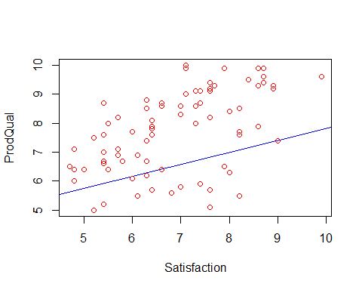

LM1 <- lm(Satisfaction~ProdQual, data = Mydata )  
summary(LM1)

##   
## Call:  
## lm(formula = Satisfaction ~ ProdQual, data = Mydata)  
##   
## Residuals:  
## Min 1Q Median 3Q Max   
## -1.88746 -0.72711 -0.01577 0.85641 2.25220   
##   
## Coefficients:  
## Estimate Std. Error t value Pr(>|t|)   
## (Intercept) 3.67593 0.59765 6.151 1.68e-08 ***  
## ProdQual 0.41512 0.07534 5.510 2.90e-07 ***  
## ---  
## Signif. codes: 0 '***' 0.001 '**' 0.01 '*' 0.05 '.' 0.1 ' ' 1  
##   
## Residual standard error: 1.047 on 98 degrees of freedom  
## Multiple R-squared: 0.2365, Adjusted R-squared: 0.2287   
## F-statistic: 30.36 on 1 and 98 DF, p-value: 2.901e-07

predict(LM1)

## 1 2 3 4 5 6 7 8   
## 7.204432 7.079896 7.495015 6.332683 7.411991 6.374195 6.540242 6.249659   
## 9 10 11 12 13 14 15 16   
## 6.083612 6.332683 7.287455 6.208148 7.619550 7.495015 6.291171 7.287455   
## 17 18 19 20 21 22 23 24   
## 6.042100 6.125124 6.000588 7.453503 5.834541 7.661062 7.245944 7.536526   
## 25 26 27 28 29 30 31 32   
## 6.166636 6.332683 7.204432 6.581754 7.204432 6.830825 6.540242 7.038384   
## 33 34 35 36 37 38 39 40   
## 6.457219 6.996872 6.457219 7.287455 7.411991 7.661062 7.079896 6.208148   
## 41 42 43 44 45 46 47 48   
## 7.121408 7.578038 7.536526 5.793029 6.996872 6.125124 7.827109 6.042100   
## 49 50 51 52 53 54 55 56   
## 7.785597 6.955361 6.457219 7.079896 7.578038 6.540242 6.996872 7.536526   
## 57 58 59 60 61 62 63 64   
## 6.747801 6.830825 7.827109 7.785597 7.287455 7.162920 7.328967 6.872337   
## 65 66 67 68 69 70 71 72   
## 6.415707 6.042100 6.042100 5.959077 6.789313 6.332683 7.453503 6.457219   
## 73 74 75 76 77 78 79 80   
## 6.374195 7.785597 7.204432 7.785597 6.830825 7.578038 7.536526 6.623266   
## 81 82 83 84 85 86 87 88   
## 7.785597 7.287455 7.245944 6.332683 6.872337 6.789313 5.751517 6.872337   
## 89 90 91 92 93 94 95 96   
## 7.453503 5.959077 7.453503 6.623266 7.495015 7.536526 7.536526 7.245944   
## 97 98 99 100   
## 6.747801 7.287455 6.913849 6.955361

cor(Satisfaction,Ecom)

## [1] 0.282745

plot(Satisfaction,Ecom, col= "red", ylim = c(0,10), abline(lm(Satisfaction~Ecom), col="blue"))

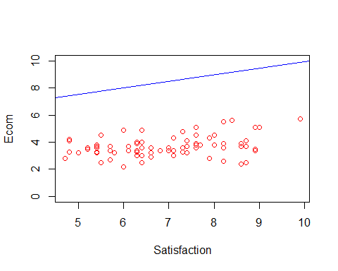

LM2 <- lm(Satisfaction~Ecom, data = Mydata)  
summary(LM2)

##   
## Call:  
## lm(formula = Satisfaction ~ Ecom, data = Mydata)  
##   
## Residuals:  
## Min 1Q Median 3Q Max   
## -2.37200 -0.78971 0.04959 0.68085 2.34580   
##   
## Coefficients:  
## Estimate Std. Error t value Pr(>|t|)   
## (Intercept) 5.1516 0.6161 8.361 4.28e-13 ***  
## Ecom 0.4811 0.1649 2.918 0.00437 **   
## ---  
## Signif. codes: 0 '***' 0.001 '**' 0.01 '*' 0.05 '.' 0.1 ' ' 1  
##   
## Residual standard error: 1.149 on 98 degrees of freedom  
## Multiple R-squared: 0.07994, Adjusted R-squared: 0.07056   
## F-statistic: 8.515 on 1 and 98 DF, p-value: 0.004368

cor(Satisfaction,TechSup)

## [1] 0.1125972

plot(Satisfaction,TechSup, col="red" , abline(lm(Satisfaction~TechSup), col="blue"))

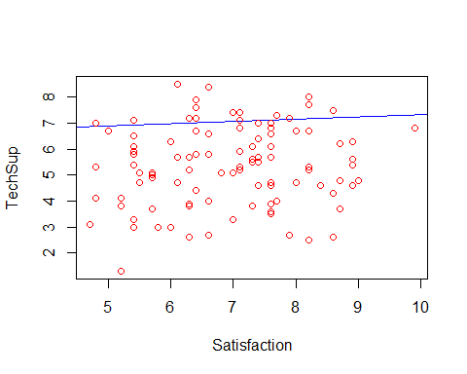

LM3 <- lm(Satisfaction~TechSup, data = Mydata)  
summary(LM3)

##   
## Call:  
## lm(formula = Satisfaction ~ TechSup, data = Mydata)  
##   
## Residuals:  
## Min 1Q Median 3Q Max   
## -2.26136 -0.93297 0.04302 0.82501 2.85617   
##   
## Coefficients:  
## Estimate Std. Error t value Pr(>|t|)   
## (Intercept) 6.44757 0.43592 14.791 <2e-16 ***  
## TechSup 0.08768 0.07817 1.122 0.265   
## ---  
## Signif. codes: 0 '***' 0.001 '**' 0.01 '*' 0.05 '.' 0.1 ' ' 1  
##   
## Residual standard error: 1.19 on 98 degrees of freedom  
## Multiple R-squared: 0.01268, Adjusted R-squared: 0.002603   
## F-statistic: 1.258 on 1 and 98 DF, p-value: 0.2647

cor(Satisfaction,CompRes)

## [1] 0.6032626

plot(Satisfaction,CompRes, col = "red", ylim= c(0,10), xlim=c(0,10),  
 abline(lm(Satisfaction~CompRes), col= "blue"))

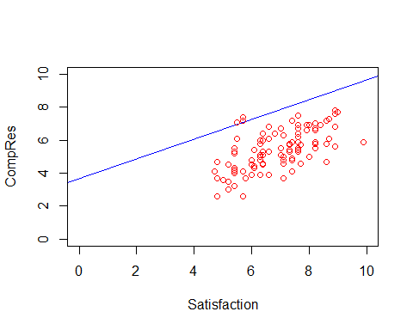

LM4 <- lm(Satisfaction~CompRes, data = Mydata)  
summary(LM4)

##   
## Call:  
## lm(formula = Satisfaction ~ CompRes, data = Mydata)  
##   
## Residuals:  
## Min 1Q Median 3Q Max   
## -2.40450 -0.66164 0.04499 0.63037 2.70949   
##   
## Coefficients:  
## Estimate Std. Error t value Pr(>|t|)   
## (Intercept) 3.68005 0.44285 8.310 5.51e-13 ***  
## CompRes 0.59499 0.07946 7.488 3.09e-11 ***  
## ---  
## Signif. codes: 0 '***' 0.001 '**' 0.01 '*' 0.05 '.' 0.1 ' ' 1  
##   
## Residual standard error: 0.9554 on 98 degrees of freedom  
## Multiple R-squared: 0.3639, Adjusted R-squared: 0.3574   
## F-statistic: 56.07 on 1 and 98 DF, p-value: 3.085e-11

cor(Satisfaction,Advertising)

## [1] 0.3046695

plot(Satisfaction,Advertising, col="red", ylim= c(0,10),  
 abline(lm(Satisfaction~Advertising), col="blue"))

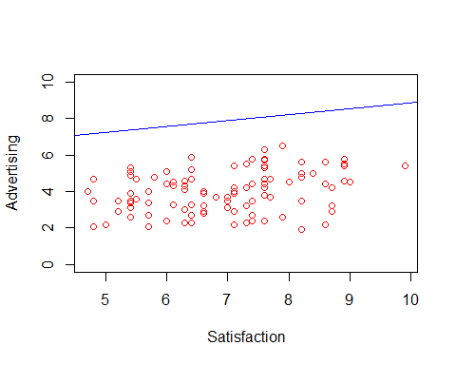

LM5 <- lm(Satisfaction~Advertising, data = Mydata)  
summary(LM5)

##   
## Call:  
## lm(formula = Satisfaction ~ Advertising, data = Mydata)  
##   
## Residuals:  
## Min 1Q Median 3Q Max   
## -2.34033 -0.92755 0.05577 0.79773 2.53412   
##   
## Coefficients:  
## Estimate Std. Error t value Pr(>|t|)   
## (Intercept) 5.6259 0.4237 13.279 < 2e-16 ***  
## Advertising 0.3222 0.1018 3.167 0.00206 **   
## ---  
## Signif. codes: 0 '***' 0.001 '**' 0.01 '*' 0.05 '.' 0.1 ' ' 1  
##   
## Residual standard error: 1.141 on 98 degrees of freedom  
## Multiple R-squared: 0.09282, Adjusted R-squared: 0.08357   
## F-statistic: 10.03 on 1 and 98 DF, p-value: 0.002056

cor(Satisfaction,ProdLine)

## [1] 0.5505459

plot(Satisfaction,ProdLine, col="red", ylim = c(0,10),  
 abline(lm(Satisfaction~ProdLine), col="blue"))

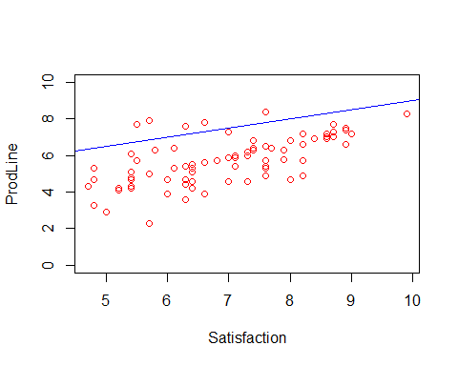

LM6 <- lm(Satisfaction~ProdLine, data = Mydata)  
summary(LM6)

##   
## Call:  
## lm(formula = Satisfaction ~ ProdLine, data = Mydata)  
##   
## Residuals:  
## Min 1Q Median 3Q Max   
## -2.3634 -0.7795 0.1097 0.7604 1.7373   
##   
## Coefficients:  
## Estimate Std. Error t value Pr(>|t|)   
## (Intercept) 4.02203 0.45471 8.845 3.87e-14 ***  
## ProdLine 0.49887 0.07641 6.529 2.95e-09 ***  
## ---  
## Signif. codes: 0 '***' 0.001 '**' 0.01 '*' 0.05 '.' 0.1 ' ' 1  
##   
## Residual standard error: 1 on 98 degrees of freedom  
## Multiple R-squared: 0.3031, Adjusted R-squared: 0.296   
## F-statistic: 42.62 on 1 and 98 DF, p-value: 2.953e-09

cor(Satisfaction,SalesFImage)

## [1] 0.5002053

plot(Satisfaction,SalesFImage, col="red", abline(lm(Satisfaction~SalesFImage), col="blue"))

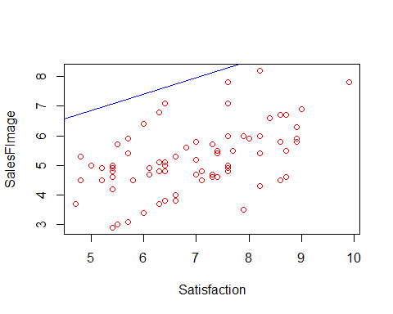

LM7 <- lm(Satisfaction~SalesFImage, data = Mydata)  
summary(LM7)

##   
## Call:  
## lm(formula = Satisfaction ~ SalesFImage, data = Mydata)  
##   
## Residuals:  
## Min 1Q Median 3Q Max   
## -2.2164 -0.5884 0.1838 0.6922 2.0728   
##   
## Coefficients:  
## Estimate Std. Error t value Pr(>|t|)   
## (Intercept) 4.06983 0.50874 8.000 2.54e-12 ***  
## SalesFImage 0.55596 0.09722 5.719 1.16e-07 ***  
## ---  
## Signif. codes: 0 '***' 0.001 '**' 0.01 '*' 0.05 '.' 0.1 ' ' 1  
##   
## Residual standard error: 1.037 on 98 degrees of freedom  
## Multiple R-squared: 0.2502, Adjusted R-squared: 0.2426   
## F-statistic: 32.7 on 1 and 98 DF, p-value: 1.164e-07

cor(Satisfaction,ComPricing)

## [1] -0.2082957

plot(Satisfaction,ComPricing, col="red", abline(lm(Satisfaction~ComPricing), col="blue"))

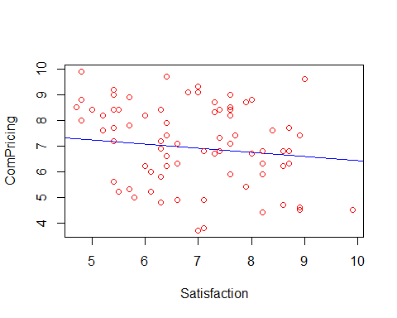

LM8 <- lm(Satisfaction~ComPricing, data = Mydata)  
summary(LM8)

##   
## Call:  
## lm(formula = Satisfaction ~ ComPricing, data = Mydata)  
##   
## Residuals:  
## Min 1Q Median 3Q Max   
## -1.9728 -0.9915 -0.1156 0.9111 2.5845   
##   
## Coefficients:  
## Estimate Std. Error t value Pr(>|t|)   
## (Intercept) 8.03856 0.54427 14.769 <2e-16 ***  
## ComPricing -0.16068 0.07621 -2.108 0.0376 *   
## ---  
## Signif. codes: 0 '***' 0.001 '**' 0.01 '*' 0.05 '.' 0.1 ' ' 1  
##   
## Residual standard error: 1.172 on 98 degrees of freedom  
## Multiple R-squared: 0.04339, Adjusted R-squared: 0.03363   
## F-statistic: 4.445 on 1 and 98 DF, p-value: 0.03756

cor(Satisfaction,WartyClaim)

## [1] 0.1775448

plot(Satisfaction,WartyClaim, col="red", abline(lm(Satisfaction~WartyClaim), col="blue"))

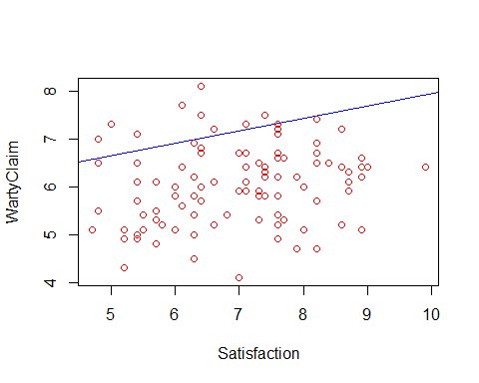

LM9 <- lm(Satisfaction~WartyClaim, data = Mydata)  
summary(LM9)

##   
## Call:  
## lm(formula = Satisfaction ~ WartyClaim, data = Mydata)  
##   
## Residuals:  
## Min 1Q Median 3Q Max   
## -2.36504 -0.90202 0.03019 0.90763 2.88985   
##   
## Coefficients:  
## Estimate Std. Error t value Pr(>|t|)   
## (Intercept) 5.3581 0.8813 6.079 2.32e-08 ***  
## WartyClaim 0.2581 0.1445 1.786 0.0772 .   
## ---  
## Signif. codes: 0 '***' 0.001 '**' 0.01 '*' 0.05 '.' 0.1 ' ' 1  
##   
## Residual standard error: 1.179 on 98 degrees of freedom  
## Multiple R-squared: 0.03152, Adjusted R-squared: 0.02164   
## F-statistic: 3.19 on 1 and 98 DF, p-value: 0.0772

cor(Satisfaction,OrdBilling)

## [1] 0.5217319

plot(Satisfaction,OrdBilling, col="red", ylim = c(0,10),   
 abline(lm(Satisfaction~OrdBilling), col="blue"))

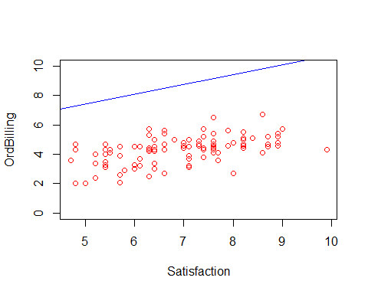

LM10 <- lm(Satisfaction~OrdBilling, data = Mydata)  
summary(LM10)

##   
## Call:  
## lm(formula = Satisfaction ~ OrdBilling, data = Mydata)  
##   
## Residuals:  
## Min 1Q Median 3Q Max   
## -2.4005 -0.7071 -0.0344 0.7340 2.9673   
##   
## Coefficients:  
## Estimate Std. Error t value Pr(>|t|)   
## (Intercept) 4.0541 0.4840 8.377 3.96e-13 ***  
## OrdBilling 0.6695 0.1106 6.054 2.60e-08 ***  
## ---  
## Signif. codes: 0 '***' 0.001 '**' 0.01 '*' 0.05 '.' 0.1 ' ' 1  
##   
## Residual standard error: 1.022 on 98 degrees of freedom  
## Multiple R-squared: 0.2722, Adjusted R-squared: 0.2648   
## F-statistic: 36.65 on 1 and 98 DF, p-value: 2.602e-08

cor(Satisfaction,DelSpeed)

## [1] 0.5770423

plot(Satisfaction,DelSpeed, col="red", ylim = c(0,10),   
 abline(lm(Satisfaction~DelSpeed), col="blue"))

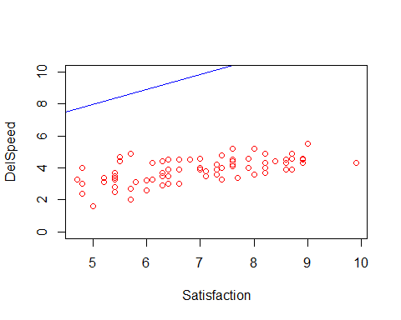

LM11 <- lm(Satisfaction~DelSpeed, data = Mydata)  
summary(LM11)

##   
## Call:  
## lm(formula = Satisfaction ~ DelSpeed, data = Mydata)  
##   
## Residuals:  
## Min 1Q Median 3Q Max   
## -2.22475 -0.54846 0.08796 0.54462 2.59432   
##   
## Coefficients:  
## Estimate Std. Error t value Pr(>|t|)   
## (Intercept) 3.2791 0.5294 6.194 1.38e-08 ***  
## DelSpeed 0.9364 0.1339 6.994 3.30e-10 ***  
## ---  
## Signif. codes: 0 '***' 0.001 '**' 0.01 '*' 0.05 '.' 0.1 ' ' 1  
##   
## Residual standard error: 0.9783 on 98 degrees of freedom  
## Multiple R-squared: 0.333, Adjusted R-squared: 0.3262   
## F-statistic: 48.92 on 1 and 98 DF, p-value: 3.3e-10

## Eigen Values extraction

EV <- eigen(Matrix)  
EV

## eigen() decomposition  
## $values  
## [1] 3.42697133 2.55089671 1.69097648 1.08655606 0.60942409 0.55188378  
## [7] 0.40151815 0.24695154 0.20355327 0.13284158 0.09842702  
##   
## $vectors  
## [,1] [,2] [,3] [,4] [,5]  
## [1,] -0.1337896 0.31349802 0.06227164 0.6431362 0.23166620  
## [2,] -0.1659528 -0.44650918 -0.23524791 0.2723803 0.42228844  
## [3,] -0.1576926 0.23096734 -0.61095105 -0.1933931 -0.02395667  
## [4,] -0.4706836 -0.01944394 0.21035078 -0.2063204 0.02865743  
## [5,] -0.1837350 -0.36366471 -0.08809705 0.3178945 -0.80387024  
## [6,] -0.3867652 0.28478056 0.11627864 0.2029023 0.11667416  
## [7,] -0.2036696 -0.47069599 -0.24134210 0.2221772 0.20437283  
## [8,] 0.1516886 -0.41345650 0.05304529 -0.3335435 0.24892601  
## [9,] -0.2129336 0.19167191 -0.59856398 -0.1853020 -0.03292706  
## [10,] -0.4372177 -0.02639905 0.16892981 -0.2368536 0.02675377  
## [11,] -0.4730891 -0.07305172 0.23262477 -0.1973299 -0.03543294  
## [,6] [,7] [,8] [,9] [,10]  
## [1,] 0.56456996 -0.191641317 0.13547311 0.03132810 -0.06659717  
## [2,] -0.26325703 -0.059626208 -0.12202642 -0.54251104 -0.28155772  
## [3,] 0.10876896 0.017199915 0.46470964 -0.35929961 0.38817090  
## [4,] 0.02815231 0.008499596 0.51339754 0.09324751 -0.53467243  
## [5,] 0.20056937 0.063069619 -0.05347713 -0.15468169 -0.03715799  
## [6,] -0.09819533 0.608147555 -0.33320710 -0.08415534 0.23479794  
## [7,] -0.10497225 -0.001437351 0.16910665 0.64489911 0.35341191  
## [8,] 0.70973595 0.308248871 -0.09883227 -0.09414389 0.04518224  
## [9,] 0.13983966 0.030640243 -0.44354040 0.31756604 -0.43534752  
## [10,] 0.11947974 -0.659319893 -0.36601754 -0.09907265 0.30386545  
## [11,] -0.02979992 0.234239274 0.06539059 -0.02188514 0.12010386  
## [,11]  
## [1,] -0.18279209  
## [2,] -0.06233863  
## [3,] 0.05192956  
## [4,] 0.36253352  
## [5,] 0.08118684  
## [6,] 0.38507778  
## [7,] 0.08469869  
## [8,] 0.10295751  
## [9,] -0.12893245  
## [10,] 0.19415064  
## [11,] -0.77563222

EigenValue <- EV$values  
EigenValue

## [1] 3.42697133 2.55089671 1.69097648 1.08655606 0.60942409 0.55188378  
## [7] 0.40151815 0.24695154 0.20355327 0.13284158 0.09842702

## Scree Plot using kaiser normalization rule to determine total number of factors

plot(EigenValue, col = "red" , pch = 20 , xlab = "Factors", ylab = "Eigen Values", main = "Scree Plot for EigenValues")  
lines(EigenValue, col = "red")

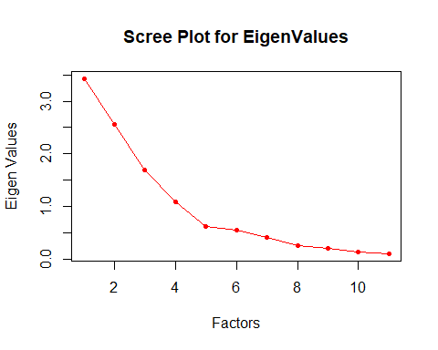

## Performing Factor Analysis to extract 4 factors

F1 <- fa(Mydata[,-12], nfactors = 4, rotate = "none", fm = "pa" )  
F1

## Factor Analysis using method = pa  
## Call: fa(r = Mydata[, -12], nfactors = 4, rotate = "none", fm = "pa")  
## Standardized loadings (pattern matrix) based upon correlation matrix  
## PA1 PA2 PA3 PA4 h2 u2 com  
## ProdQual 0.20 -0.41 -0.06 0.46 0.42 0.576 2.4  
## Ecom 0.29 0.66 0.27 0.22 0.64 0.362 2.0  
## TechSup 0.28 -0.38 0.74 -0.17 0.79 0.205 1.9  
## CompRes 0.86 0.01 -0.26 -0.18 0.84 0.157 1.3  
## Advertising 0.29 0.46 0.08 0.13 0.31 0.686 1.9  
## ProdLine 0.69 -0.45 -0.14 0.31 0.80 0.200 2.3  
## SalesFImage 0.39 0.80 0.35 0.25 0.98 0.021 2.1  
## ComPricing -0.23 0.55 -0.04 -0.29 0.44 0.557 1.9  
## WartyClaim 0.38 -0.32 0.74 -0.15 0.81 0.186 2.0  
## OrdBilling 0.75 0.02 -0.18 -0.18 0.62 0.378 1.2  
## DelSpeed 0.90 0.10 -0.30 -0.20 0.94 0.058 1.4  
##   
## PA1 PA2 PA3 PA4  
## SS loadings 3.21 2.22 1.50 0.68  
## Proportion Var 0.29 0.20 0.14 0.06  
## Cumulative Var 0.29 0.49 0.63 0.69  
## Proportion Explained 0.42 0.29 0.20 0.09  
## Cumulative Proportion 0.42 0.71 0.91 1.00  
##   
## Mean item complexity = 1.9  
## Test of the hypothesis that 4 factors are sufficient.  
##   
## The degrees of freedom for the null model are 55 and the objective function was 6.55 with Chi Square of 619.27  
## The degrees of freedom for the model are 17 and the objective function was 0.33   
##   
## The root mean square of the residuals (RMSR) is 0.02   
## The df corrected root mean square of the residuals is 0.03   
##   
## The harmonic number of observations is 100 with the empirical chi square 3.19 with prob < 1   
## The total number of observations was 100 with Likelihood Chi Square = 30.27 with prob < 0.024   
##   
## Tucker Lewis Index of factoring reliability = 0.921  
## RMSEA index = 0.096 and the 90 % confidence intervals are 0.032 0.139  
## BIC = -48.01  
## Fit based upon off diagonal values = 1  
## Measures of factor score adequacy   
## PA1 PA2 PA3 PA4  
## Correlation of (regression) scores with factors 0.98 0.97 0.95 0.88  
## Multiple R square of scores with factors 0.96 0.95 0.91 0.78  
## Minimum correlation of possible factor scores 0.92 0.90 0.82 0.56

fa.diagram(F1)

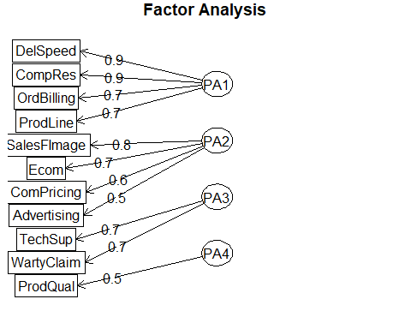

F2 <- fa(Mydata[,-12], nfactors = 4, rotate = "varimax", fm= "pa")  
F2

## Factor Analysis using method = pa  
## Call: fa(r = Mydata[, -12], nfactors = 4, rotate = "varimax", fm = "pa")  
## Standardized loadings (pattern matrix) based upon correlation matrix  
## PA1 PA2 PA3 PA4 h2 u2 com  
## ProdQual 0.02 -0.07 0.02 0.65 0.42 0.576 1.0  
## Ecom 0.07 0.79 0.03 -0.11 0.64 0.362 1.1  
## TechSup 0.02 -0.03 0.88 0.12 0.79 0.205 1.0  
## CompRes 0.90 0.13 0.05 0.13 0.84 0.157 1.1  
## Advertising 0.17 0.53 -0.04 -0.06 0.31 0.686 1.2  
## ProdLine 0.53 -0.04 0.13 0.71 0.80 0.200 1.9  
## SalesFImage 0.12 0.97 0.06 -0.13 0.98 0.021 1.1  
## ComPricing -0.08 0.21 -0.21 -0.59 0.44 0.557 1.6  
## WartyClaim 0.10 0.06 0.89 0.13 0.81 0.186 1.1  
## OrdBilling 0.77 0.13 0.09 0.09 0.62 0.378 1.1  
## DelSpeed 0.95 0.19 0.00 0.09 0.94 0.058 1.1  
##   
## PA1 PA2 PA3 PA4  
## SS loadings 2.63 1.97 1.64 1.37  
## Proportion Var 0.24 0.18 0.15 0.12  
## Cumulative Var 0.24 0.42 0.57 0.69  
## Proportion Explained 0.35 0.26 0.22 0.18  
## Cumulative Proportion 0.35 0.60 0.82 1.00  
##   
## Mean item complexity = 1.2  
## Test of the hypothesis that 4 factors are sufficient.  
##   
## The degrees of freedom for the null model are 55 and the objective function was 6.55 with Chi Square of 619.27  
## The degrees of freedom for the model are 17 and the objective function was 0.33   
##   
## The root mean square of the residuals (RMSR) is 0.02   
## The df corrected root mean square of the residuals is 0.03   
##   
## The harmonic number of observations is 100 with the empirical chi square 3.19 with prob < 1   
## The total number of observations was 100 with Likelihood Chi Square = 30.27 with prob < 0.024   
##   
## Tucker Lewis Index of factoring reliability = 0.921  
## RMSEA index = 0.096 and the 90 % confidence intervals are 0.032 0.139  
## BIC = -48.01  
## Fit based upon off diagonal values = 1  
## Measures of factor score adequacy   
## PA1 PA2 PA3 PA4  
## Correlation of (regression) scores with factors 0.98 0.99 0.94 0.88  
## Multiple R square of scores with factors 0.96 0.97 0.88 0.78  
## Minimum correlation of possible factor scores 0.93 0.94 0.77 0.55

fa.diagram(F2)

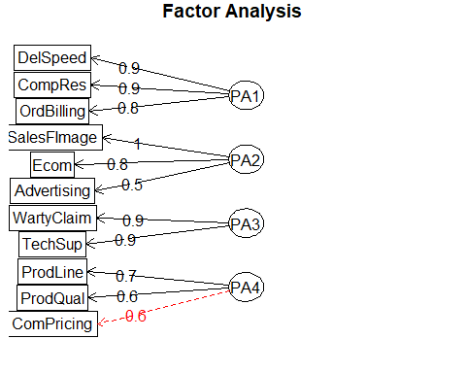

F2$scores

## PA1 PA2 PA3 PA4  
## [1,] -0.13388710 0.91751661 -1.719604873 0.09135411  
## [2,] 1.62976040 -2.00900531 -0.596361722 0.65808192  
## [3,] 0.36376581 0.83617362 0.002979966 1.37548765  
## [4,] -1.22252302 -0.54913358 1.245473305 -0.64421384  
## [5,] -0.48542093 -0.42762231 -0.026980304 0.47360747  
## [6,] -0.59509240 -1.30353334 -1.183019401 -0.95913571  
## [7,] -2.52885363 0.38836877 -0.603275803 -1.29659025  
## [8,] -0.11315168 -0.13097631 -0.699238481 -1.36606005  
## [9,] 0.95751096 0.34755882 -0.142256076 -0.93477420  
## [10,] 0.58135807 0.43427719 -0.481549064 -0.66519579  
## [11,] -0.04744554 -0.34677999 -0.477931226 0.62086386  
## [12,] -1.22969845 1.22373499 0.307420873 -1.06601488  
## [13,] 0.70120038 1.40162126 -0.077278204 0.61198552  
## [14,] 0.18944710 -0.12001589 0.341391428 1.43748733  
## [15,] 1.59586476 0.51484865 -0.307216912 -0.62265003  
## [16,] 1.11215548 -1.25985548 -0.535588676 0.99091689  
## [17,] 0.90477581 -0.30392244 0.909413294 -1.04926552  
## [18,] 1.35863182 0.09820639 0.147598367 -0.63536585  
## [19,] 0.76821232 0.25113902 -0.444327163 -0.84712501  
## [20,] 0.61161128 1.74911250 -0.747772366 -0.37770002  
## [21,] -0.49662748 -0.40513549 1.413398115 -1.42620085  
## [22,] -0.24583333 2.83259042 0.458183224 2.15737479  
## [23,] -0.08593028 -0.20647990 0.954813784 1.29099542  
## [24,] 1.30419410 -0.65840510 -0.735880788 0.79535237  
## [25,] 0.02837015 0.11289267 0.352466288 -0.83695432  
## [26,] 0.37516895 -0.08949421 0.586591370 -1.33839027  
## [27,] 0.69040218 -1.27676215 0.980470048 0.97700863  
## [28,] 0.19330562 -1.09019060 0.410744110 -1.15018948  
## [29,] 0.74807174 -1.20388888 -0.169444094 1.11442401  
## [30,] -0.53645976 -0.31470400 -1.389463973 -0.62508147  
## [31,] -0.98478652 -0.32465411 2.054616799 0.57213335  
## [32,] -0.89540824 -1.30592549 1.145669622 -0.17981750  
## [33,] -0.61006900 -0.25385457 0.201747129 -0.51103804  
## [34,] 0.58139098 -0.57102185 0.160508882 -1.09267691  
## [35,] -1.08254233 1.61817367 0.121735970 -0.32924397  
## [36,] -1.51860194 -1.82264781 0.280394795 1.08323735  
## [37,] -0.54298600 -0.45867623 0.359185746 0.44557509  
## [38,] 1.35035690 0.28270522 0.116158567 0.69743150  
## [39,] 0.98244317 -0.26293227 -1.015054009 -0.98172621  
## [40,] -0.92383910 1.28059000 -1.167921851 -0.79331056  
## [41,] 0.09932064 0.09827305 -1.837451060 -0.63276007  
## [42,] 0.10869713 -0.04357923 -1.050920110 0.49209145  
## [43,] 0.44811474 1.20846081 -0.968824054 0.72015394  
## [44,] 0.70660340 2.17850627 1.233358555 -0.84868686  
## [45,] 1.38263370 -2.03732511 -0.954180731 0.77953010  
## [46,] 0.94936859 0.24232567 0.291172997 -0.56344261  
## [47,] 0.08771633 -0.60985289 0.976205747 0.45795642  
## [48,] 1.81030056 0.43834059 0.814478797 -1.17962559  
## [49,] -0.19224074 1.62888205 -0.733730711 1.33934942  
## [50,] 0.22531882 0.78430768 -0.957752366 0.92784955  
## [51,] -1.41135829 -0.16930613 0.091870699 -0.12631052  
## [52,] 1.75365232 -1.99153570 -1.147542434 0.70646283  
## [53,] 0.93209854 -0.51397965 -0.162358377 0.70759613  
## [54,] -0.94184081 -0.25288506 0.358406630 0.67268912  
## [55,] 0.72242047 -0.54924734 -0.909388995 -1.09941166  
## [56,] -0.63244099 0.41450294 0.914064214 0.81720176  
## [57,] 1.99193341 1.41977208 -0.077384854 -0.41266731  
## [58,] 0.08548402 0.30077469 0.319615332 0.74357193  
## [59,] -0.57061091 -0.34885418 0.365475898 0.45601852  
## [60,] 0.83067496 -1.65626897 0.641678078 0.23244952  
## [61,] 0.86635294 -1.24543164 1.546930711 0.94382806  
## [62,] -0.60680134 0.74525730 -0.146586558 -0.25509333  
## [63,] -1.00306329 -0.09710517 -1.081705300 0.42111790  
## [64,] -1.28310920 -1.59838664 0.403626668 -0.02388625  
## [65,] -1.39461685 -0.23395772 0.557826636 -0.26460336  
## [66,] 1.60952000 0.55610373 -0.999093684 -1.16665258  
## [67,] 1.07257520 -0.39772241 1.815878900 -1.14631126  
## [68,] 0.50884788 -0.29395183 -0.416389316 -0.75909753  
## [69,] -0.70601563 -0.44707894 -0.973611521 -0.83304582  
## [70,] 0.23899120 0.05018369 -1.219545924 -1.27828253  
## [71,] 0.48631145 1.74069413 0.854795068 -0.43411595  
## [72,] -1.37477720 -0.22770098 -1.265787815 1.00015839  
## [73,] 0.76539809 0.81612817 -1.748046205 -0.13852761  
## [74,] -0.64249465 1.66245576 1.253902625 1.20305576  
## [75,] -0.26909538 0.83656999 -0.210138132 -0.11412392  
## [76,] -0.12296694 -0.33391431 1.172210398 0.39677906  
## [77,] 0.10371878 -0.33487753 2.082854211 -1.18017022  
## [78,] 0.46301479 -0.33956677 1.214737442 0.10357998  
## [79,] 0.98918468 0.65624508 0.485336460 1.22733204  
## [80,] -1.74919939 0.82890385 0.003384046 0.09231225  
## [81,] -0.32137992 -0.20110631 0.470666208 0.60888606  
## [82,] -0.03471489 -0.38974940 0.412648407 0.57771035  
## [83,] -1.17790878 -0.90045717 0.198122454 0.40011473  
## [84,] -2.55956258 -0.25686675 1.554283149 -1.14101556  
## [85,] 0.73971919 -0.90696938 0.655846983 0.51129012  
## [86,] -0.50161741 -0.56408382 -1.009145207 -0.86106988  
## [87,] -1.33057806 -0.01745886 -2.201996451 -0.92403144  
## [88,] 0.70358137 -0.91236060 1.299031585 0.56968494  
## [89,] 0.10912530 -0.46505791 0.266161987 0.17120142  
## [90,] 1.02813129 2.57446865 1.640665437 -0.80151398  
## [91,] -1.04672561 0.44260491 1.394021786 0.75011393  
## [92,] -1.90712581 -0.46993540 -0.522475751 -1.31422452  
## [93,] 0.07279015 -0.02235421 -0.352359525 1.61044504  
## [94,] 1.08706436 0.61924340 0.089460676 1.16081123  
## [95,] -0.95457978 0.66256003 -0.981787816 1.06717592  
## [96,] -0.41931326 0.70755398 -0.077703201 0.52522023  
## [97,] -0.12315824 -0.25275815 -1.762967608 -0.63424275  
## [98,] -1.79270636 -1.59315365 -1.309147686 1.28219570  
## [99,] -0.33991434 1.89138931 0.122487640 -0.17511674  
## [100,] -0.31758889 -0.42356050 -0.453981729 -1.03250054

## New data frame with the independent variable and four factor scores

FactorRegressiondata <- cbind(Mydata[,12], F2$scores)  
head(FactorRegressiondata)

## PA1 PA2 PA3 PA4  
## [1,] 8.2 -0.1338871 0.9175166 -1.719604873 0.09135411  
## [2,] 5.7 1.6297604 -2.0090053 -0.596361722 0.65808192  
## [3,] 8.9 0.3637658 0.8361736 0.002979966 1.37548765  
## [4,] 4.8 -1.2225230 -0.5491336 1.245473305 -0.64421384  
## [5,] 7.1 -0.4854209 -0.4276223 -0.026980304 0.47360747  
## [6,] 4.7 -0.5950924 -1.3035333 -1.183019401 -0.95913571

## Naming the factors

colnames(FactorRegressiondata) <- c("Satisfaction", "Fulfillment", "Business", "AfterService", "Product")

## Convert to data frame

FactorsBusiness <- as.data.frame(FactorRegressiondata)  
head(FactorsBusiness)

## Satisfaction Fulfillment Business AfterService Product  
## 1 8.2 -0.1338871 0.9175166 -1.719604873 0.09135411  
## 2 5.7 1.6297604 -2.0090053 -0.596361722 0.65808192  
## 3 8.9 0.3637658 0.8361736 0.002979966 1.37548765  
## 4 4.8 -1.2225230 -0.5491336 1.245473305 -0.64421384  
## 5 7.1 -0.4854209 -0.4276223 -0.026980304 0.47360747  
## 6 4.7 -0.5950924 -1.3035333 -1.183019401 -0.95913571

is.data.frame(FactorsBusiness)

## [1] TRUE

attach(FactorsBusiness)

## The following object is masked from Mydata:  
##   
## Satisfaction

## Multiple linear regression with the 4 factors

MLR <- lm(Satisfaction~Fulfillment+Business+AfterService+Product , data = FactorsBusiness)  
summary(MLR)

##   
## Call:  
## lm(formula = Satisfaction ~ Fulfillment + Business + AfterService +   
## Product, data = FactorsBusiness)  
##   
## Residuals:  
## Min 1Q Median 3Q Max   
## -1.7125 -0.4708 0.1024 0.4158 1.3483   
##   
## Coefficients:  
## Estimate Std. Error t value Pr(>|t|)   
## (Intercept) 6.91800 0.06696 103.317 < 2e-16 ***  
## Fulfillment 0.57963 0.06857 8.453 3.32e-13 ***  
## Business 0.61978 0.06834 9.070 1.61e-14 ***  
## AfterService 0.05692 0.07173 0.794 0.429   
## Product 0.61168 0.07656 7.990 3.16e-12 ***  
## ---  
## Signif. codes: 0 '***' 0.001 '**' 0.01 '*' 0.05 '.' 0.1 ' ' 1  
##   
## Residual standard error: 0.6696 on 95 degrees of freedom  
## Multiple R-squared: 0.6971, Adjusted R-squared: 0.6844   
## F-statistic: 54.66 on 4 and 95 DF, p-value: < 2.2e-16

## Data Partitioning

set.seed(1234)  
split <- sample.split(Satisfaction, SplitRatio = 0.7)  
TrainData <- subset(FactorsBusiness,split == T)  
TestData <- subset(FactorsBusiness, split == F)  
dim(TrainData)

## [1] 71 5

dim(TestData)

## [1] 29 5

## Multiple regression using train data

MLR <- lm(Satisfaction~., data = TrainData)  
summary(MLR)

##   
## Call:  
## lm(formula = Satisfaction ~ ., data = TrainData)  
##   
## Residuals:  
## Min 1Q Median 3Q Max   
## -1.07153 -0.42578 -0.01652 0.38619 1.27831   
##   
## Coefficients:  
## Estimate Std. Error t value Pr(>|t|)   
## (Intercept) 6.925120 0.066212 104.590 < 2e-16 ***  
## Fulfillment 0.553473 0.066208 8.360 6.02e-12 ***  
## Business 0.750898 0.068772 10.919 < 2e-16 ***  
## AfterService -0.001064 0.069597 -0.015 0.988   
## Product 0.525923 0.069971 7.516 1.94e-10 ***  
## ---  
## Signif. codes: 0 '***' 0.001 '**' 0.01 '*' 0.05 '.' 0.1 ' ' 1  
##   
## Residual standard error: 0.5554 on 66 degrees of freedom  
## Multiple R-squared: 0.8049, Adjusted R-squared: 0.7931   
## F-statistic: 68.09 on 4 and 66 DF, p-value: < 2.2e-16

vif(MLR)

## Fulfillment Business AfterService Product   
## 1.011048 1.005816 1.000977 1.006056

## Validation on test data

Prediction <- predict(MLR, newdata = TestData)  
SST <- sum((TestData$Satisfaction - mean(TrainData$Satisfaction))^2)  
SST

## [1] 36.27184

SSE <- sum((Prediction - TestData$Satisfaction)^2)  
SSE

## [1] 24.93798

SSR <- sum((Prediction - mean(TrainData$Satisfaction))^2)  
SSR

## [1] 20.04646

SSR/SST

## [1] 0.5526728

## Backtracking of the model on test data

Prediction <- predict(MLR, newdata = TestData)  
Actual <- TestData$Satisfaction  
Backtrack <- data.frame(Prediction,Actual)  
Backtrack

## Prediction Actual  
## 9 7.224591 7.0  
## 10 7.223655 5.5  
## 25 6.585045 4.8  
## 31 6.434997 6.1  
## 32 5.353129 6.4  
## 33 6.127863 5.4  
## 35 7.367760 6.3  
## 39 6.756209 7.6  
## 40 6.959416 6.0  
## 48 7.634964 7.6  
## 51 5.950312 5.4  
## 52 6.773045 5.7  
## 53 7.427379 8.7  
## 59 6.586790 7.1  
## 60 6.262755 7.9  
## 62 7.014881 8.0  
## 63 6.519662 6.3  
## 69 5.761567 5.2  
## 74 8.449232 8.6  
## 76 6.813754 7.1  
## 78 6.979589 7.6  
## 82 6.916636 7.4  
## 83 5.807246 6.6  
## 88 6.927672 8.2  
## 89 6.726062 7.3  
## 90 9.004048 8.2  
## 94 8.602172 8.9  
## 95 7.456598 7.7  
## 99 8.065000 6.4

plot(Prediction, col= "red")  
lines(Prediction , col= "red")

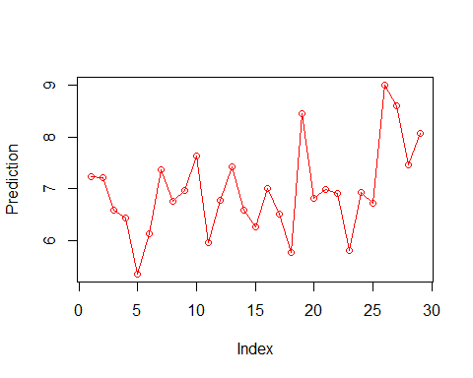

plot(Actual, col="blue")  
lines(Actual, col="blue")

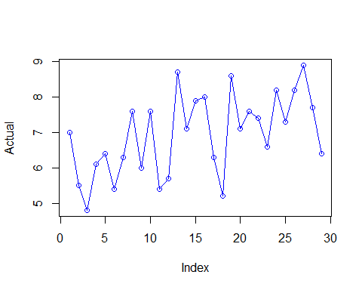

## Backtracking of the model on train data

Prediction2 <- predict(MLR, newdata = TrainData)  
Actual2 <- TrainData$Satisfaction  
Backtrack1 <- data.frame(Prediction2, Actual2)  
  
plot(Prediction2, col= "red")  
lines(Prediction2 , col= "red")

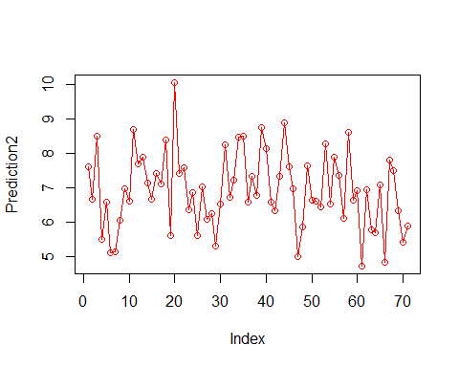

plot(Actual2, col="blue")  
lines(Actual2, col="blue")

